📄 Calculation Definitions for Global Cancer Dashboard
Each calculation below is to be implemented as an SQL query for data validation and preparation.

✅ General KPIs
- Total Cancer Cases : Count of all unique Patient_ID.
  - SELECT COUNT(*) AS Total_Cases FROM cancer;
  - 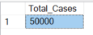

- Total Cancer Cases (Current Year) : Count of Patient_ID where Year = 2024.
SELECT COUNT(*) AS total_cases_for_current_year FROM cancer WHERE YEAR = 2024;
  - 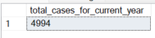

- Year-on-Year Growth Rate: Percentage change in case count between current year and previous year.
WITH DATA AS
(SELECT Year,COUNT(*) AS CY_Cases,
LAG (COUNT(*), 1) OVER(ORDER BY YEAR) AS PY_Cases
FROM cancer
GROUP BY YEAR)

SELECT *, CONCAT(
CASE
WHEN PY_Cases IS NULL THEN 0
ELSE CAST(ROUND(((CY_Cases-PY_Cases)*1.0/PY_Cases)*100,2) AS DECIMAL(10,2))
END
,'%') AS YoY_Growth_Rate
FROM DATA;
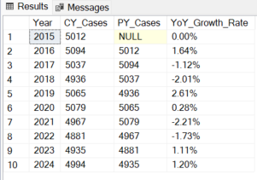

- Top Affected Country: Country_Region with the highest number of patients.
SELECT TOP 1 Country_Region, COUNT(*) AS Num_Of_Cases FROM CANCER
GROUP BY Country_Region
ORDER BY COUNT(*) DESC;
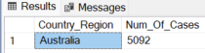

- Most Common Cancer Type: Mode (most frequent value) of Cancer_Type.
SELECT TOP 1 cancer_type, count(*) AS Num_Of_Cases FROM cancer
GROUP BY cancer_type
ORDER BY count(*) DESC;
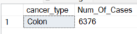
- Male vs Female Ratio: Ratio of count of Gender = 'Male' to count of Gender = 'Female'.
SELECT gender, count(*) as num_of_cases,
CONCAT(CAST(count(*)*1.0/(SELECT COUNT(*) FROM cancer) AS DECIMAL(10,2)),'%') AS '%age of total'
FROM cancer
GROUP BY gender;
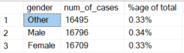

- Average Cases per Country: Total number of Patient_ID divided by number of distinct Country_Region.
SELECT count(*)/(select count(distinct Country_Region) FROM cancer) AS Avg_Of_Cases
FROM cancer;
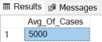

- Most Affected Age Group: Group ages into bins (e.g., 0–20, 21–40, etc.) and return the group with the highest number of patients.
WITH age_class AS
(SELECT Patient_id, age,
CASE
WHEN age>10 AND age<21 THEN '10-20'
WHEN age>20 AND age<31 THEN '21-30'
WHEN age>30 AND age<41 THEN '31-40'
WHEN age>40 AND age<51 THEN '41-50'
WHEN age>50 AND age<61 THEN '51-60'
WHEN age>60 AND age<71 THEN '61-70'
WHEN age>70 AND age<81 THEN '71-80'
WHEN age>80 AND age<91 THEN '81-90'
ELSE null
END AS 'age_group'
FROM cancer)

SELECT TOP 1 age_group as Most_affected_age_group, count(*) AS num_of_cases FROM age_class
GROUP BY age_group
ORDER BY count(*) DESC;
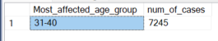

- Average Treatment Cost: Average of Treatment_Cost_USD.
SELECT CAST(AVG(Treatment_Cost_USD) AS DECIMAL(10,2)) as AVG_Treatment_Cost FROM cancer;
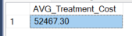

- Average Survival Years: Average of Survival_Years.
SELECT CAST(AVG(Survival_Years) AS DECIMAL(10,2)) as AVG_Survival_Years FROM cancer;
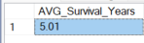

- Severity Risk Index: Average of Target_Severity_Score.
SELECT CAST(AVG(Target_Severity_Score) AS DECIMAL(10,2)) as AVG_Target_Severity_Score FROM cancer;
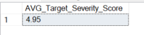

📊 Visual-Specific Calculations
- Yearly Cancer Trend: Count of Patient_ID grouped by Year.
SELECT Year, COUNT(Patient_ID) AS num_of_cases FROM cancer GROUP BY Year ORDER BY Year;
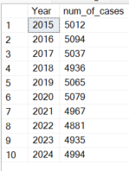

- Cancer Cases by Country: Count of Patient_ID grouped by Country_Region.3
SELECT Country_Region, COUNT(Patient_ID) AS num_of_cases FROM cancer GROUP BY Country_Region ORDER BY Country_Region;
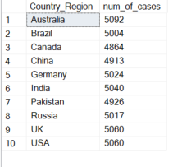

- Cancer Cases by Type: Count of Patient_ID grouped by Cancer_Type.
SELECT Cancer_Type, COUNT(Patient_ID) AS num_of_cases FROM cancer GROUP BY Cancer_Type ORDER BY Cancer_Type;
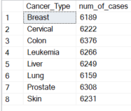

- Cancer Cases by Gender: Count of Patient_ID grouped by Gender.
SELECT Gender, COUNT(Patient_ID) AS num_of_cases FROM cancer GROUP BY Gender ORDER BY Gender;
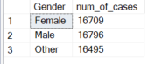

- Cancer Cases by Age Group: Count of Patient_ID grouped by binned Age.
WITH age_class AS
(SELECT Patient_id, age,
CASE
WHEN age>10 AND age<21 THEN '10-20'
WHEN age>20 AND age<31 THEN '21-30'
WHEN age>30 AND age<41 THEN '31-40'
WHEN age>40 AND age<51 THEN '41-50'
WHEN age>50 AND age<61 THEN '51-60'
WHEN age>60 AND age<71 THEN '61-70'
WHEN age>70 AND age<81 THEN '71-80'
WHEN age>80 AND age<91 THEN '81-90'
ELSE null
END AS 'age_group'
FROM cancer)

SELECT age_group as Most_affected_age_group, count(*) AS num_of_cases FROM age_class
GROUP BY age_group
ORDER BY age_group;
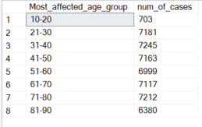

- Top 5 Countries by Specific Cancer Type: For each Cancer_Type, return the top 5 Country_Region by patient count.
WITH base_data as
(SELECT Cancer_Type, Country_Region, COUNT(Patient_ID) AS num_of_cases
FROM cancer GROUP BY Cancer_Type, Country_Region),

final_data as
(SELECT Cancer_Type, Country_Region, num_of_cases,
DENSE_RANK() OVER(PARTITION BY cancer_type ORDER BY num_of_cases DESC) as rnk
FROM base_data)

SELECT Cancer_Type, Country_Region, num_of_cases, rnk as Rank
FROM final_data
WHERE rnk<6;
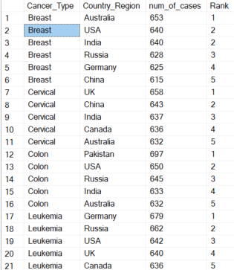
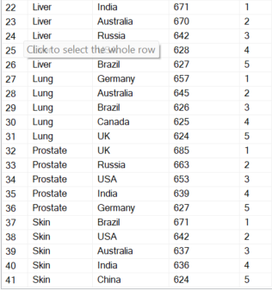
- Country vs Year Heatmap: Create a matrix of Patient_ID count for each combination of Country_Region and Year.
SELECT Year, Country_Region, COUNT(Patient_ID) as Num_of_Cases
FROM cancer
GROUP BY Year, Country_Region
ORDER BY Year, Country_Region;
Year | Country_Region | Num_of_Cases
2015 | Australia | 515
2015 | Brazil | 499
2015 | Canada | 511
2015 | China | 529
2015 | Germany | 473
2015 | India | 515
2015 | Pakistan | 460
2015 | Russia | 512
2015 | UK | 490
2015 | USA | 508
2016 | Australia | 516
2016 | Brazil | 525
2016 | Canada | 478
2016 | China | 533
2016 | Germany | 503
2016 | India | 508
2016 | Pakistan | 506
2016 | Russia | 493
2016 | UK | 499
2016 | USA | 533
2017 | Australia | 484
2017 | Brazil | 508
2017 | Canada | 481
2017 | China | 535
2017 | Germany | 512
2017 | India | 507
2017 | Pakistan | 499
2017 | Russia | 524
2017 | UK | 493
2017 | USA | 494
2018 | Australia | 492
2018 | Brazil | 504
2018 | Canada | 489
2018 | China | 474
2018 | Germany | 517
2018 | India | 477
2018 | Pakistan | 451
2018 | Russia | 501
2018 | UK | 524
2018 | USA | 507
2019 | Australia | 525
2019 | Brazil | 496
2019 | Canada | 490
2019 | China | 477
2019 | Germany | 519
2019 | India | 504
2019 | Pakistan | 500
2019 | Russia | 515
2019 | UK | 522
2019 | USA | 517
2020 | Australia | 535
2020 | Brazil | 485
2020 | Canada | 502
2020 | China | 514
2020 | Germany | 478
2020 | India | 532
2020 | Pakistan | 501
2020 | Russia | 507
2020 | UK | 525
2020 | USA | 500
2021 | Australia | 472
2021 | Brazil | 492
2021 | Canada | 501
2021 | China | 444
2021 | Germany | 484
2021 | India | 519
2021 | Pakistan | 517
2021 | Russia | 504
2021 | UK | 513
2021 | USA | 521
2022 | Australia | 513
2022 | Brazil | 506
2022 | Canada | 487
2022 | China | 460
2022 | Germany | 507
2022 | India | 470
2022 | Pakistan | 481
2022 | Russia | 492
2022 | UK | 497
2022 | USA | 468
2023 | Australia | 554
2023 | Brazil | 491
2023 | Canada | 437
2023 | China | 496
2023 | Germany | 503
2023 | India | 505
2023 | Pakistan | 490
2023 | Russia | 473
2023 | UK | 488
2023 | USA | 498
2024 | Australia | 486
2024 | Brazil | 498
2024 | Canada | 488
2024 | China | 451
2024 | Germany | 528
2024 | India | 503
2024 | Pakistan | 521
2024 | Russia | 496
2024 | UK | 509
2024 | USA | 514

💲 Cost and Severity Analysis
- Average Treatment Cost by Cancer Type: Average of Treatment_Cost_USD grouped by Cancer_Type.
SELECT Cancer_Type, CAST(AVG(Treatment_Cost_USD) AS DECIMAL(10,2)) as AVG_Treatment_Cost
FROM cancer
GROUP BY Cancer_Type;
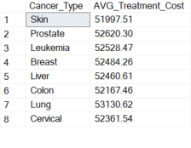

- Average Severity by Cancer Type: Average of Target_Severity_Score grouped by Cancer_Type.
SELECT Cancer_Type, CAST(AVG(Target_Severity_Score) AS DECIMAL(10,2)) as AVG_Target_Severity_Score
FROM cancer
GROUP BY Cancer_Type;
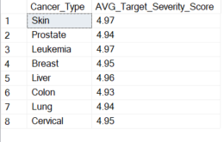

- Average Severity by Age Group: Average of Target_Severity_Score grouped by binned Age.
WITH age_class AS
(SELECT Patient_id, age, Target_Severity_Score,
CASE
WHEN age>10 AND age<21 THEN '10-20'
WHEN age>20 AND age<31 THEN '21-30'
WHEN age>30 AND age<41 THEN '31-40'
WHEN age>40 AND age<51 THEN '41-50'
WHEN age>50 AND age<61 THEN '51-60'
WHEN age>60 AND age<71 THEN '61-70'
WHEN age>70 AND age<81 THEN '71-80'
WHEN age>80 AND age<91 THEN '81-90'
ELSE null
END AS 'age_group'
FROM cancer)

SELECT age_group, CAST(AVG(Target_Severity_Score) AS DECIMAL(10,2)) as AVG_Target_Severity_Score
FROM age_class
GROUP BY age_group
ORDER BY age_group;
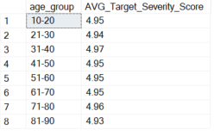

📉 Risk Factor & Outcome Correlation
- Average Genetic Risk Score: Average of Genetic_Risk.
SELECT CAST(AVG(Genetic_Risk) AS decimal(10,2)) AS Average_Genetic_Risk_Score FROM cancer;
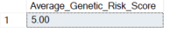

- Average Air Pollution Exposure: Average of Air_Pollution.
SELECT CAST(AVG(Air_Pollution) AS decimal(10,2)) AS Average_Air_Pollution FROM cancer;
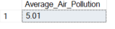

- Smoking vs Severity Score: Table of Smoking and corresponding Target_Severity_Score for scatter plot.
WITH base_data as
(SELECT
CASE
WHEN Smoking =0 THEN '0'
WHEN Smoking >0 and Smoking<1 THEN '>0 Smoking'
WHEN Smoking >=1 and Smoking<2 THEN '>=1 Smoking'
WHEN Smoking >=2 and Smoking<3 THEN '>=2 Smoking'
WHEN Smoking >=3 and Smoking<4 THEN '>=3 Smoking'
WHEN Smoking >=4 and Smoking<5 THEN '>=4 Smoking'
WHEN Smoking >=5 and Smoking<6 THEN '>=5 Smoking'
WHEN Smoking >=6 and Smoking<7 THEN '>=6 Smoking'
WHEN Smoking >=7 and Smoking<8 THEN '>=7 Smoking'
WHEN Smoking >=8 and Smoking<9 THEN '>=8 Smoking'
WHEN Smoking >=9 and Smoking<10 THEN '>=9 Smoking'
WHEN Smoking >=10 THEN '>=10 Smoking'
ELSE Null
END as 'Smoking_categ', *
FROM cancer)

SELECT Smoking_categ, AVG(Target_Severity_Score) as Avg_Target_Severity_Score
FROM base_data
GROUP BY Smoking_categ ORDER BY Avg_Target_Severity_Score DESC;
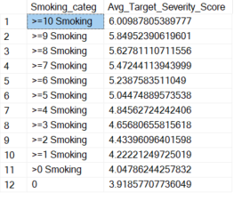

- Survival Years vs Severity Score: Table of Survival_Years and Target_Severity_Score for outcome analysis.
SELECT CAST(Survival_Years as Int) as Survival_Years, CAST(AVG(Target_Severity_Score) AS DECIMAL(10,2)) as Avg_Target_Severity_Score
FROM cancer
GROUP BY CAST(Survival_Years as Int)
Order BY Survival_Years;
